**4PxU_ RPISB**

**HW Specifications**

4 Port USB Hub Raspberry Pi Stacking Board

Revision 0.3

Designer: Joseph John Bayalas

Email: [jbayalas@mindlabtech.com](mailto:jbayalas@mindlabtech.com)

**Revision History:**

|  |  |  |  |
| --- | --- | --- | --- |
| Revision No. | Description | Date | Author |
| 0.1 | First draft. |  | Jbayalas |
| 0.2 | Added 3D drawings | 02/04/2014 | Jbayalas |
| 0.3 | Added PCB snap shot  Updated the PCB stack-up section. | 02/16/2014 | Jbayalas |
|  |  |  |  |
|  |  |  |  |
|  |  |  |  |
|  |  |  |  |

Table of Contents

2 Project/Design Details: 4

3 Introduction 4

4 Product Requirements 4

5 Sytems Overview 5

6 Hardware Implementation 5

6.1 5V Power Outlet Connector 5

6.2 Uptream USB 2.0 Port 5

6.3 Downsteam USB 2.0 Ports 5

6.4 5V Power Inlet Connector 6

6.4.1 Power Distribution 6

6.5 USB Hub Controller 7

7 Physical Implementation 7

7.1 PCB Stackup 7

7.2 Board Outline 7

7.3 Component Placement 8

7.4 Stacking Profile 10

7.5 PCB markings 12

# Project/Design Details:

|  |  |
| --- | --- |
| Customer | Chris |
| Project Name | 4 Port USB Hub Raspberry Pi Stacking Board |
| Design Code/Name | 4PxU_RPISB |
| Author | Joseph Bayalas |
| Date | February 2, 2014 |

# Introduction

4PxU_RPISB is a stackable USB 2.0 hub that fits on the bottom of a revision B RaspberryPi (Rpi). The stacking board will provide adequate current capacity to power up RPi. The board will be stacked with Rpi’s bottom side.

The product will be the solution for the scarcity of USB hubs that is able to provide adequate power and mechanicaly work well with the small form factor of RPi.

This document will serve as product requirement and hardware specification document. This will also serve as guide for the Hardware, Layout, Mechanical and Manufacturing Engineers on how the product will be implemented.

The product will be prototype in Philippines and eventually manufacturing will be moved to US.

# Product Requirements

| **Requirements** | **Descriptions** | **Comments** |
| --- | --- | --- |
| Req. 1 | RPi 5V Power Outlet (USB Type A Receptacle) | To be reviewed by the customer. |
| Req. 2 | RPi upstream port (USB Mini B Receptacle) | To be reviewed by the customer. |
| Req. 3 | 4 Port Type A Receptacle | To be reviewed by the customer. |
| Req. 4 | Req. 1 should be mechanically aligned to RPi S1 connector. |  |
| Req. 5 | Req. 2 should be mechanically aligned to RPi S7 connector. |  |
| Req. 6 | External 5V DC power supply connector (5.5mm x 2.1mm Barrel Jack) | To be reviewed by the customer. |
| Req. 7 | Board Outline should match RPi rev B including mounting holes. |  |
| Req. 8 | Overall height must be minimized. | To be reviewed by the customer. |
| Req. 9 | Board shall be mounted underneath RPi. | To be reviewed by the customer. |
| Req. 10 | Manufacturing will be moved to US. |  |
| Req. 11 | Eagle files and libraries must be provided. |  |
| Req. 12 | Prototypes will be provided. |  |

# Sytems Overview

The block diagram shows the interconnection between the RPi and the stacking board.

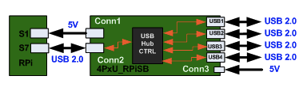

# Hardware Implementation

## 5V Power Outlet Connector

S1 of RPi will be connected to Conn 1 of the stacking board. Conn 1 of the stacking board serves as a 5V power outlet to supply power on the RPi and its peripherals. This connector will be implemented with a USB Type A receptacle.

A 2A Fuse will be added to this port for safety precautions. RPi should only draw maximum of 1.5A on this port.

## Uptream USB 2.0 Port

One of the USB port of the 2x USB(S7) connector will be connected to the uptream port (Conn 2) of the stacking board. This connector will be implemeted using a USB mini B receptacle.

## Downsteam USB 2.0 Ports

There will be 4 USB 2.0 Ports.

Each of the ports will have the ff:

1. EMI Filters for the 5V Vbus line
2. EMI Filter for the USB lines
3. ESD protection Diodes
4. Current Limiter on 5V Vbus line
5. Port Power Status LED

## 5V Power Inlet Connector

This is where the external power supply will be connected. The connector will use a 5mm x 2.1mm barrel jack. A low voltage drop diode will be connected to the positive line of the jack to protect from accidental polarity reversal by the user. Voltage clamp will also be provided for over voltage protection.

### Power Distribution

The external power supply must be a 4A, 5V power supply. The power supply is from TBD supplier.

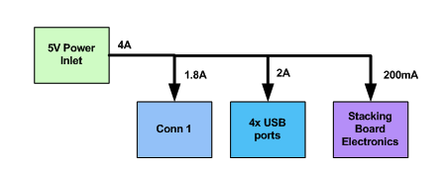

Here’s the power budget:

|  |  |  |
| --- | --- | --- |
| **Component** | **Consumption (A)** | **Description** |
| Conn 1 | 1.8 | 5V Power Outlet |
| USB1 | 0.5 | USB port 1 |
| USB2 | 0.5 | USB port 2 |
| USB3 | 0.5 | USB port 3 |
| USB4 | 0.5 | USB port 4 |
| Stacking board | 0.2 | Consumption for the stacking board connector. |
| Total | 4 | A |

## USB Hub Controller

The USB Hub controller chip that will be used is USB2514BQFN36 from SMSC.

Details will be provided later…

# Physical Implementation

## PCB Stackup

The PCB will be a 2 layer board.

Top 🡪 1 oz

Prepreg 🡪 31 mils

Bottom 🡪 1 oz

## Board Outline

Top:

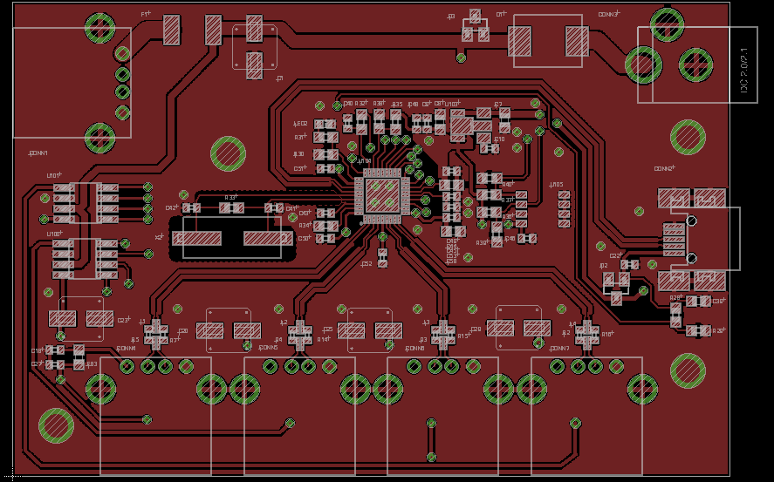

Bottom:

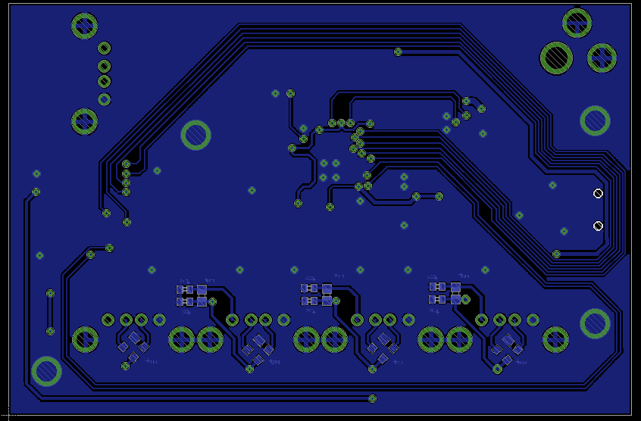

## Component Placement

## 

MH1 and MH2 is for RPi stacking.

MH3 and MH4 is for user applications.

Top View:

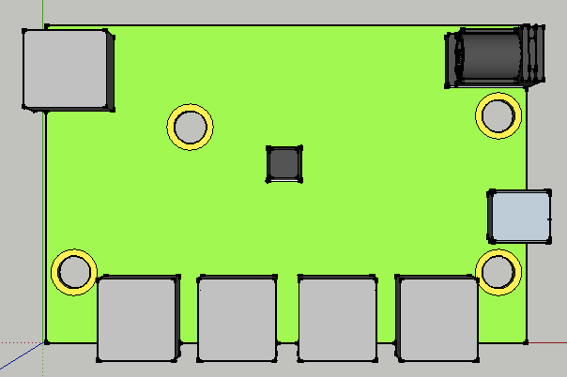

Bottom View:

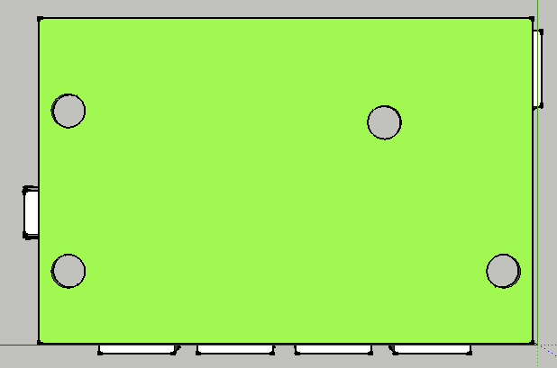

Front View:

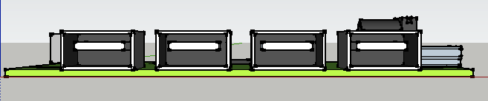

Back View:

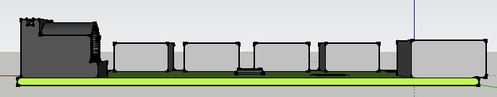

Left View:

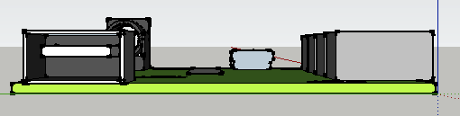

Right View:

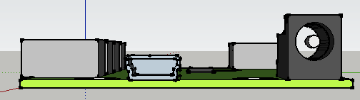

Isometric View:

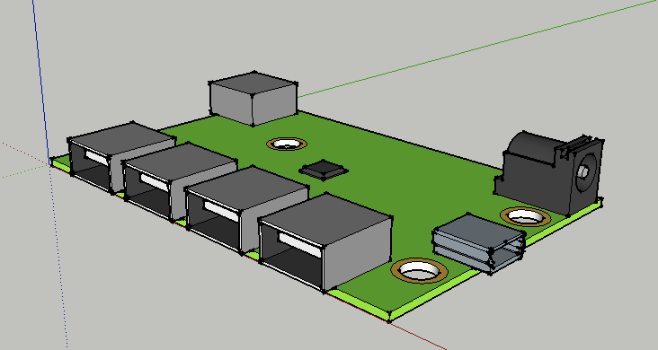

## Stacking Profile

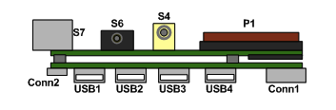

Top View:

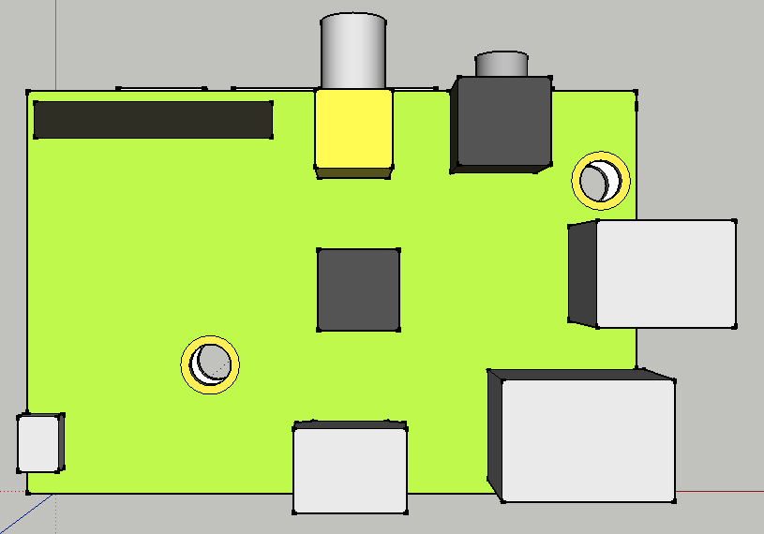

Bottom View:

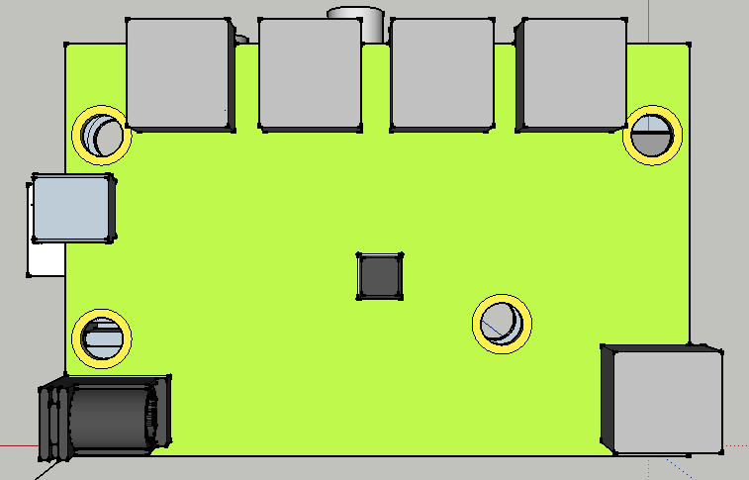

Front View:

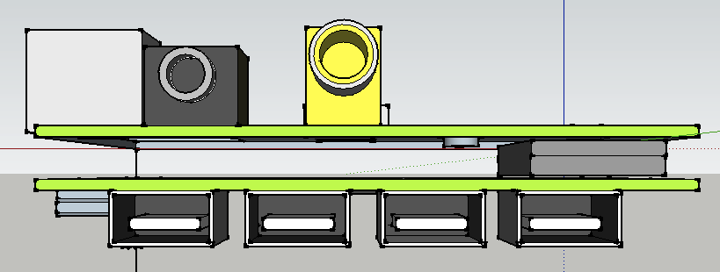

Back View:

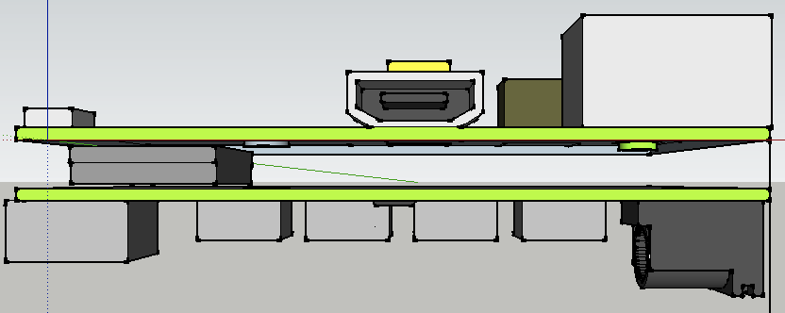

Left View:

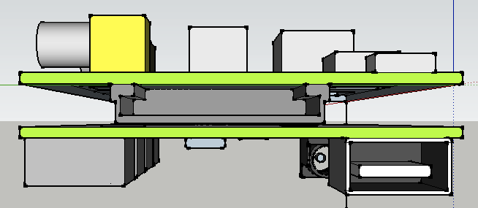

Right View:

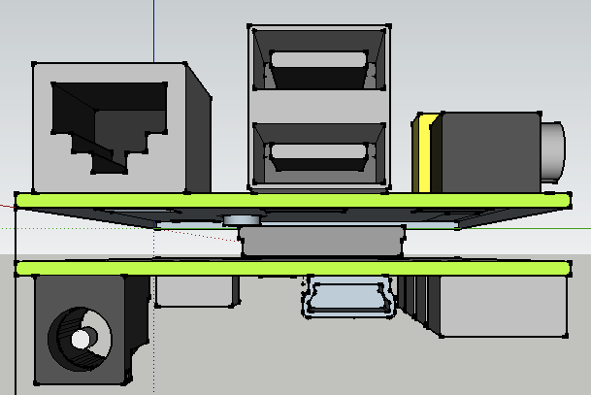

Isometric View:

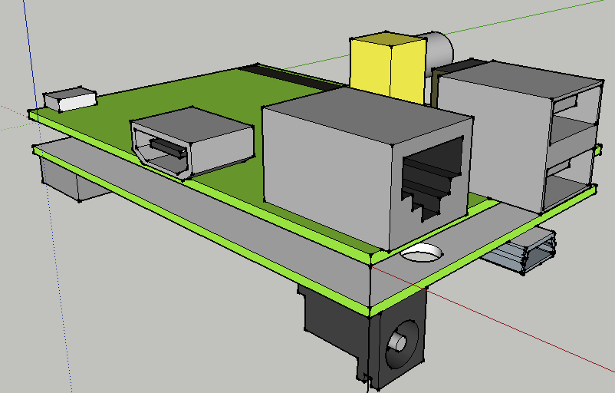

## PCB markings

TBD